Experiment 6: Version Control and Collaboration using Git and GitHub

1. **git init** → Initializes a new Git repository in the current folder.



2. **git remote add origin <url>** → Connects the local repo to a remote GitHub repository.

3. **git remote -v** → Displays the remote repositories linked with the project.

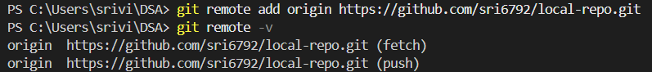

4. **echo "text" > file.txt** → Creates a new file with the given text (used to generate test files).

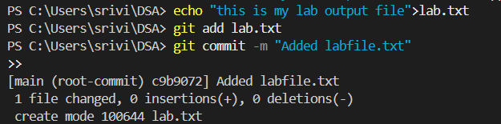

5. **git add <file>** → Adds changes/files to the staging area for commit.

6. **git status** → Shows the current status of the working directory and staged changes.

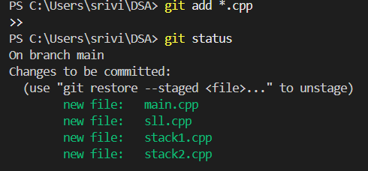

7. **git commit -m "message"** → Records the staged changes with a descriptive message.

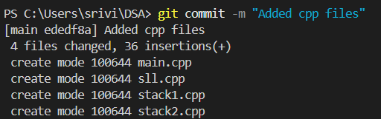

8. **git pull origin main --rebase** → Fetches and applies changes from the remote repo before pushing.

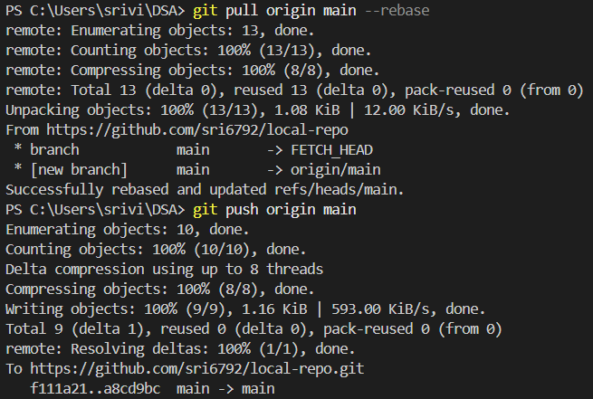

9. git log --oneline

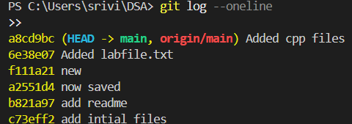

10. **git branch** → Lists all branches in the repository and shows the current branch.

